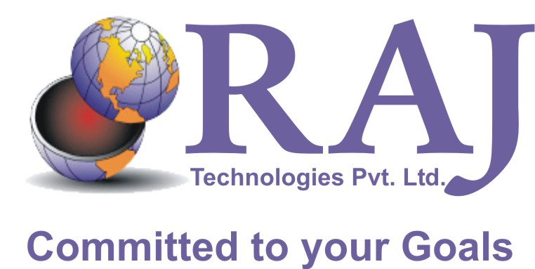

COMPANY PROFILE

_________________________________________

About Raj Technologies:-
Raj Technologies Pvt. Ltd. incorporated in 2002 as an entity promoted by well-qualified engineers, computer professionals and businessmen specialized in Data Conversion, IT Enabled Services, Software Development and 2D Animation who bring with them several years of business and professional experience. This rich experience of promoters in various industries helps the organization assimilate customer requirement at a faster pace.

The Company Believes:-
"Perfection through innovation"
“Set the constant innovation as our key for achieving the ultimate goal of success and emerge as a global company by providing the superior quality services and solutions."

In the global business arena, the world has been divided into small platforms in order to deliver the market requisites in no time. The rapid growth and mind-boggling pace of changes in the technology has compelled the business world to integrate for the latest technology amendments. The changing face of technology has rendered a different dimension to the vision of management gurus in the business world. Amalgamation of new concepts and techniques with business has become an advanced mantra for the business realm.

Of late Indian information technology has been considered to be a force to reckon with, India has established a formidable reputation worldwide. We at Raj Technologies Pvt. Ltd. have decided to take the technology to the doorstep of the global customer. In our stride of growth and in exploring new frontiers of technology, we wish to benefit the industries by organizing their work, optimizing their resource requirements and stretching there reach to the prospective customer; there by enhancing their market share and helping those to explore new business avenues with more efficient and fruitful business practice.

Raj Technologies Pvt. Ltd. routinely meets myriad challenges in the technology arena and synchronizes solutions to meet the changing faces of the business world. We help you adhere to your strict schedules and deadlines and there by serve your customer better.

Our value proposition: - delivering on-time, premier quality, best cost services

___________________________________________

Our Motto
"Excellence in customer's need based solutions and services"
We strive to deliver outstanding quality of work through a dedicated team of professionals using Innovative Ideas and Flexible working methods. We always keep in mind, the trust and mutual respect required by our clients in all aspects of our business and ensures the same by our high levels of integrity.

Philosophy and Strategy
In order to assist the IT needs of the business world; Raj Technologies Pvt. Ltd. focuses its interest in providing the best technological and service oriented solutions. The main aim for this concern is to make our presence in entire business world; ranging from big Corporate to small-scale industries, and to automate their process through our sophisticated systems and solutions that are:-
- Proven
- Scalable
- Interoperable
- Innovative
- Customized to individual power needs and requirements

Our strategy is to be part of the growth of IT, based on customer satisfaction, innovation and effective use of technology. To achieve this, we would recruit the best people. We have the following strategies:-

Long term:
To be recognized by our peers as a high value company with technical excellence and industry involvement, to be the market leader achieving trade industry awards and high-end of scale financial ratios. Our key thrust technological areas are: e-business and mobile computing Joint ventures and alliances will be the building blocks for business expansion.
Short term:
Aggressive recruitment of the best technical staff in emerging technological areas of the industry, increase productivity by investing in employee training and education, setting-up joint ventures and alliances in new markets viz. Dubai, Germany, France, USA, Singapore, Finland, Netherlands, South Africa and New Zealand Diversify as an Internet Service Provider.

___________________________________________

Lines of Businesses:-

These lines of businesses are keys to Raj Technology’s strength and forte in securing turnkey projects and delivery of technologically innovative end-to-end solutions. Our services:-

- E-business Solutions/Strategies
- Software Development
- Web Development
- Web Promotion
- Graphic design
- Corporate Presentation
- Domain Registration
- Web Hosting
- Internet Marketing

  - Data Conversion
- Conversion of scanned documents (in jpeg / tif / pdf formats) into text or MS word format.
- Conversion of data provided in hard copies to requisite formats.
- Digitization of Maps, Architectural Drawings, Engineering Drawings using AutoCAD, and ESRI suite of products.

Multimedia Animation
- Designing of Characters, scenes and backgrounds.
- Conversion of Scripts into finished animated clips using Flash.
- 2D Animation.
- 3D Animation and Movie production.
- Web designing and hosting.

- Software Development
- Quality Assessment Application Tool for ITES
- Production Application Tool for Data Conversion Jobs.
- Word/Line Count Application Tool for Data Conversion and Transcription
- Data Distribution and monitoring software for local Networks
- Clinical Prenatal Hospital Record Maintenance System

___________________________________________

Technologies:
The company invests significantly in research and development of new technology and improving domain expertise. This helps us understand better, how technology influences a customers’ business and provides insights on how we can help them gain competitive edge. To be precisely committed to our customers, we amplify these latest technological in our services:

Web and Scripting | XML, JavaScript, VBscript, HTML, CSS, ASP, JSP, CGI, PERL, WAP, WML, ASP+, DHTML
Server Software | SQL Server 2000, Oracle, Postgres SQL, Commerce Server 2000, Terminal Server, Site Server, Transaction Server, MSMQ, Internet Information Server, Share Point Server, MS Exchange Server 2000
Application Servers | BEA's WebLogic, IBM's WebSphere, iPlanet Application Server
Enterprise Applications | Siebel, Talisma, i2, Manugistics
Middleware and Messaging | MQSeries, MQWork Flow, MQ Integrator, Forte Fusion/iPlanet Integration Server, iPlanet Message server, MS Host Integration server, BizTalk, MSMQ, Tibco, eUnify
Testing Tools | Win runner, Silk Test, SQA suite, Load runner, Silk performer, Web load
Operating Systems | Windows NT/2000, Windows XP, Windows CE, Windows 9x, Linux, UNIX

___________________________________________

People behind the Company and Partners

Why us?
- Strong "Hands-on", diversified, operational background of key personnel.
- Ability to Produce High Quality Work.
- Ability to Deliver Products with reference to Client Standard on time every time.
- Balance between Operational and Capital concerns.
- Cost effective designing, lower downtime, and reduced costs to maximize facility utilization and expansion potentials.

Strong relationships with leading technology entities allow us to stay ahead of the technology curve. Strategic business alliances coupled with sound understanding of technology enables us to provide the right mix of technology and services to best suit our customers’ requirements.

State-of-the-art facilities, secure infrastructure
At Raj our systems are designed to work on resilient, secure infrastructure that is spread across locations and channeled by high-end communications links, ensuring our customers’ business is safe in any eventuality.

Our Core Assets
Our manpower team, which is the core asset at Raj, comprises of Core Professionals in the areas of Data Conversion, ITES, Multimedia, Software Development and Transcription apart from operators in the 2D animation, transcription and data conversion fields. This multi-disciplinary team allows us to approach a project with a wider scope in thinking.

The individual project teams brainstorm together to provide a reality test for one another and also to share their unique viewpoints. We have been very responsive to our customer’s needs and changing requirements. We have taken on and successfully completed projects which other firms hesitated to attempt.

We assure our customers of the right mix of professionals and personnel to complete a project professionally and cost-effectively. Our professionals include Software Engineers, Digital Animators, Artists, Engineers, Technicians as well as Support personnel.

Where and How we do it…………?????????

___________________________________________

How do we ensure the best?

At Raj we assure our customers of our adherence to the highest quality standards through careful documentation and implementation of a Project Quality Plan, which details quality responsibilities, controls, processes and procedures.

We monitor and control the quality of services provided through a combination of task and process audits, checklists, inspections, the allocation of individual responsibility and accountability for the work undertaken, and timely reporting and documentation.

Confidentiality
At Raj we realize that we deal with highly confidential data from our clients. We therefore ensure that we take utmost care in maintaining such confidentiality within our organization too.
Our measures include confidentiality compliance agreements with our own employees, limited and secure access to the premises, and controlled access to internal storage devices and dissemination of information strictly on a need to know basis.

Reach Us:-
Contact Person:
Mr. Jitendra Ravia
Managing Director
Cell: 09426051111
Cell: 09824932064
E-mail: jitendra@rajtechnologies.com

Address:
2, Harsiddhi Complex, Ahmedabad
Pin - 380 014. (Gujarat), India
Call Us at: - 079-22841219

Support:
E-mail: info@rajtechnologies.com
Creative:
E-mail: creative@rajtechnologies.com

